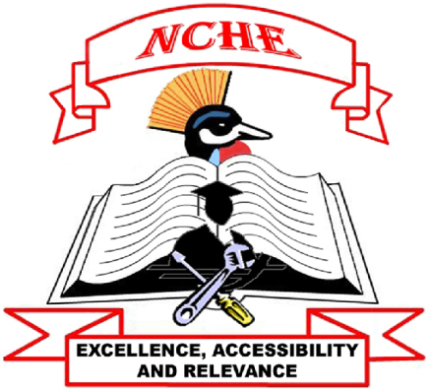

MEMBERS OF THE NATIONAL COUNCIL FOR HIGHER EDUCATION

No | Names | Constituency | Designation
1 | Prof. Eli Rwakishaya - Katunguka | Senates of Public Universities | Chairperson
2 | Prof. Joy C. Kwesiga | Vice Chancellors, Public Universities | Vice Chairperson
3 | Hajji Dr. Ramathan Mugalu | Religious Organization (UMSC) | Member
4 | Dr. Pr. Israel Kafeero | Religious Organization (SDA) | Member
5 | Rev. Dr. Paul G. Kakooza | Religious Organization (CoU) | Member
6 | Hon. Dr. Abbas Agaba Mugisha | General Public | Member
7 | Dr. Jenipher Twebaze Musoke | Commerce | Member
8 | Dr. Jane Egau Okou | Ministry of Education and Sports | Member
9 | Dr. Martin Francis Kyeyune | Industry | Member
10 | Ms. Agnes Nasirumbi | Persons with Disabilities | Member
11 | Prof. John Mugisha | Vice Chancellors of Private Universities | Member
12 | Prof. K.M. Mathew | Senates of Private Universities | Member
13 | Dr. Dick N. Kamuganga | Agricultural sector (UNFF) | Member
14 | Mr. Kateregga Francis | National Technical Colleges (NTC) | Member
15 | Mr. Katongole Mike | Student Representative (Universities) | Member
16 | Mr. Andrew Musaazi | Uganda Technical Colleges(NTCs) | Member
17 | Prof. Mary J.N. Okwakol | Executive Director, NCHE | Secretary

COMMITTEES OF THE NATIONAL COUNCIL FOR HIGHER EDUCATION

QUALITY ASSURANCE AND ACCREDITATION COMMITTEE

No | Names | Constituency | Designation
1 | Prof. Joy C. Kwesiga | Vice Chancellors, Public Universities | Chairperson
2 | Dr. Jane Egau Okou | MoES | Member
3 | Prof. K.M. Mathew | Senates of Private Universities | Member
4 | Rev. Dr. Paul Kakooza | Religious Organization (CoU) | Member
5 | Mr. Kateregga Francis | NTCs | Member
6 | Mr. Andrew Musaazi | UTCs | Member
7 | Dr. Dick N. Kamuganga | Agricultural sector (UNFF) | Member
8 | Prof. Mary J.N. Okwakol | Executive Director | Secretary

ICT, RESEARCH & INNOVATIONS COMMITTEE
No | Names | Constituency | Designation
1 | Dr. Jenipher Twebaze Musoke | Commerce | Chairperson,
2 | Hajji Dr. Ramathan Mugalu | Religious Organization (UMSC) | Member
3 | Prof. Joy C. Kwesiga | Vice Chancellors, Public Universities | Member
4 | Dr. Martin Francis Kyeyune | Industry | Member
5 | Rev. Dr. Paul Kakooza | Religious Organization (CoU) | Member
6 | Mr. Kateregga Francis | NTCs | Member
7 | Mr. Katongole Mike | Student Representative (Universities) | Member
8 | Prof. Mary J.N. Okwakol | Executive Director | Secretary

FINANCE AND MANAGEMENT COMMITTEE

No | Names | Constituency | Designation
1 | Hajji Dr. Ramathan Mugalu | Religious Organization (UMSC) | Chairperson
2 | Hon. Dr. Abbas Agaba Mugisha | General Public | Member
3 | Dr. Jenipher Twebaze Musoke | Commerce | Member
4 | Dr. Jane Egau Okou | MoES | member
5 | Dr. Martin Francis Kyeyune | Industry | Member
6 | Prof. John Mugisha | Vice Chancellors of Private Universities | Member
7 | Mr. Katongole Mike | Student Representative (Universities) | Member
8 | Prof. Mary J.N. Okwakol | Executive Director | Secretary

AUDIT & RISK MANAGEMENT COMMITTEE

No | Names | Constituency | Designation
1 | Hon. Dr. Agaba Abbas Mugisa | General Public | Chairperson
2 | Dr. Pr. Israel Kafeero | Religious Organization (SDA) | Member
3 | Ms. Agnes Nasirumbi | Disabilities | Member
4 | Prof. K.M. Mathew | Senates of Private Universities | Member
5 | Dr. Dick N. Kamuganga | Agricultural sector (UNFF) | Member

No | Names | Constituency | Designation
1 | Dr. Pr. Israel Kafeero | Religious Organization (SDA) | Chairperson
2 | Dr. Jane Egau Okou | MoES | Member
3 | Ms. Agnes Nasirumbi | Disabilities | Member
4 | Prof. John Mugisha | Vice Chancellors of Private Universities | Member
5 | Mr. Andrew Musaazi | UTCs | Member
6 | Prof. Mary J.N. Okwakol | Executive Director | Secretary
HUMAN RESOURCE MANAGEMENT COMMITTEE

